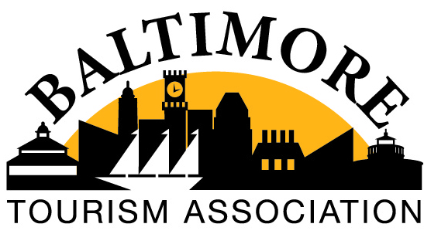
May General Meeting 2021
With BTA secretary, Dana Kirn (Maryland Zoo), absence, BTA President Chris Riehl (Rent-A-Tour) provided the following notes and information in regards to the meeting:
Thanks to all those that were able to join us at St. Mary's last week for our first in-person meeting in more than a year! It was a beautiful day and it felt so good to see so many people face to face. We had about 15 people in person and another 12-15 on Zoom.

The meeting was a lively discussion of what everyone is experiencing right now as we reopen and what challenges we're facing. There were several issues that I think BTA can be directly helpful in addressing, specifically employee wellness/morale, parking, and labor shortages. Let's all be thinking about proactive ways we can help address these things.

I haven't had a chance to review the recorded meeting but I want to make sure we share the link Mia sent that includes sources of aid. (www.baltimoretogether.com/covidresources). This is something I think we can share on our social media platforms too (more than once).

Here's the link to the full meeting. Maybe we can just send this out to everyone rather than type meeting notes? Let me know what you think.

https://us02web.zoom.us/rec/share/rcWq4CjhtObbYAGNxIjofzigl_9IC1FBSU2O79UAL8OX1paMVO9uBZYDfCmodMM.T-lxK6Iar-_mV4wo Passcode: J&tw$4u!

Also, thanks for your feedback on board expectations. I really appreciate all of the thought you put into this. I think I managed to compile all of the info I received. Please take some time to review and let me know if you think anything should be added or amended.

I also want to start thinking about a midyear retreat where we can re-evaluate the goals we set at the beginning of the year and make some new goals moving forward. I'd love to get this on the calendar in June. Please let me know what your availability is and if you have any ideas on where we could meet.

Thanks to you all for all of your hard work. I'm very excited about the rest of the of year and what's in store for us all!

Chris

--
Chris Riehl
President
Rent-A-Tour
410-464-7994
www.rentatour.com

