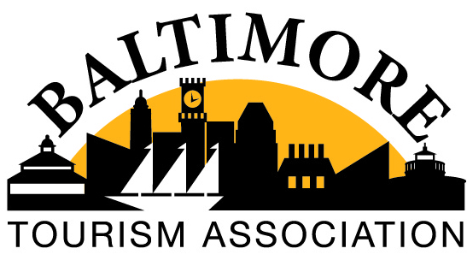
General Meeting – March 11, 2021
Virtual Meeting via Zoom
Copy the link below to share this recording with viewers:
https://us02web.zoom.us/rec/share/hM3n-6N3AYtXOtqvXFV3vClHfcUKm_4P_BZ7SdddvqKA8geJFJQ-X9CxldHnm32A.r7ePzF59oorQNn9o Passcode: sD4p.$0K
9:00am – BTA president Chris Riehl (Rent-a-Tour) welcomed everyone to the meeting and focused everyone’s attention to guest presenter, Keith Daw of McDonell Consulting / Sandler Training.
Presentation / Topic
Keith presented “How to Become a Master Communicator” covered “DISC” personalities and how to identify and coincide with these four types of personalities in your professional and personal lives. To view this presentation, please refer to the attached document. Attached document: March General Meeting - Sandler McDonell Consulting Presentation -DISC Master 2020
2021 Dues
Chris and several attendees thanked Keith for his insightful presentation. Next Chris informed BTA members that the BTA board met the prior week and made the following decision in regards to BTA Membership Dues for 2021. BTA will not require that dues be paid for the remainder of 2021 due to the pandemic, however, all members will be receiving an invoice in the amount of $150 that will also include a line to write-in what amount the member can pay if anything. No member will be penalized for not paying but BTA does need all member information submitted with the invoice for proper record keeping. BTA will be sending out 2022 Dues invoices in September. Chris encouraged everyone to inform colleagues and friends about this opportunistic time to become BTA Members. Please refer anyone who is interested to join BTA to the BTA website: https://docs.google.com/forms/d/e/1FAIpQLSdKgR34SqeP3pEegekQk_rjlTzJOWEXa6j97W4cUVDx8w1H6g/viewform.
BTA is hopeful that with your help the organization can grow its membership and become even more of a resource to its members and the community.
BTA Committee Reports
Vice President Scott Barr (National Aquarium) informed everyone that the next BTA meeting is scheduled for Thursday, April 8 at 9am via Zoom. The forum will include a conversation with some tour operators. Learn how these tour operators are dealing with the pandemic and what they are expecting in the next upcoming year. Scott noted that if any member would like to any other tour operators to join the meeting, please let him know. Please email Scott at sbarr@aqua.org.
Treasurer Mike Haynie (Maryland Center for Hospitality Training) presented the Treasurer’s Report that noted the BTA has $33,255.37 in the bank.
Membership Co-Chair Dana Twardowski (McCormick & Schmick’s Restaurant) noted that co-chair Allison Bruce (Fogo de Chao Restaurant) was not able to join the meeting due to another work commitment. Dana reported the BTA will be having at Phillips Seafood Restaurant on March 30 a hybrid BTA Networking event from 4pm-6pm. Dana referred to Michelle Torres (Phillips Seafood Restaurant) for event details. Michelle announced that the networking event will take place inside the restaurant and not on the crab deck. BTA will have one whole side of the restaurant and everything will be set up to adhere to social distancing and safety precautions. The event will offer some favorite Phillips food items including crabs. BTA will provide a complimentary first drink. There will also be Basket Bingo for both in-person and Zoom attendees. BTA is collecting donations from its members for Basket Bingo. A 50/50 is also planned. It is sure to be a fun time so plan to attend in-person or virtually! Don’t forget to invite colleagues or friends that you think may benefit from BTA too!
Marketing Co-Chair Caitlin Feeley (Select Event Group) reminded everyone to sign up for BTA’s social media takeover weeks. It’s a great way to promote your venue or organization and free with your BTA membership. You can sign up on the BTA website https://docs.google.com/spreadsheets/d/1v0rYoU-4Os5O1Lx5ZY6O8uYr0gyVwz1OPtTPe2yXGdU/edit#gid=1037186334. Marketing Co-Chair Jen McIIwain was not able to attend the meeting.
Outreach Co-Chairs Danielle Emich (Fairfield Inn) and Rebecca Gisriel (Hotel Monaco) were not able to attend the meeting but Chris reported on their behalf that they are reaching out to tour operators with a survey as well as planning some virtual events for some tour operators. More information to come.
Legislative & By – Laws Chair Jack Tomalis (Roadeo) was not able to attend the meeting. Chris reported on his behalf that the Explore Maryland Tax Credit bill will offer citizens a tax credit for utilizing hotels and attractions that are 50 miles within their residences. Chris advised everyone to be on the lookout for this information and to support it because it is expected to boost the tourism industry.
Advisors Rich Gilbert (Office of Maryland Tourism) and Eric Masterton (Visit Baltimore) were unable to attend the meeting. Ruth Toomey, Executive Director of the Maryland Tourism Coalition was in attendance and advised BTA members to sign up for the MTC e-newsletter where all legislative bills and information are disseminated for the State of Maryland.
Community Outreach & Engagement Chair – this position is currently vacant.
The meeting adjourned around 10:30am.
Meeting Minutes submitted by BTA Secretary, Dana Kirn (Maryland Zoo)

